CMSC 204

Huffman Lab

Create a Huffman Tree and generate the codes for each character of the following input:

how now brown cow

For consistency:

1. If same priority and single character – put in priority queue alphabetically
2. Add subtrees to end of group with same priority
3. Lower number has higher priority (goes to front)

|  |  |
| --- | --- |
| Char | Freq |
| o | 4 |
| w | 4 |
| Space | 3 |
| n | 2 |
| b | 1 |
| c | 1 |
| h | 1 |
| r | 1 |

|  |  |  |  |  |  |  |  |
| --- | --- | --- | --- | --- | --- | --- | --- |
| 1 | 1 | 1 | 1 | 2 | 3 | 4 | 4 |
| ‘b’ | ‘c’ | ‘h’ | ‘r’ | ‘n’ | ‘ ’ | ‘o’ | ‘w’ |

|  |  |  |  |  |  |  |
| --- | --- | --- | --- | --- | --- | --- |
| 1 | 1 | 2 | 2 | 3 | 4 | 4 |
| ‘h’ | ‘r’ | ‘n’ |  | ‘ ’ | ‘o’ | ‘w’ |

‘c’

‘b’

|  |  |  |  |  |  |
| --- | --- | --- | --- | --- | --- |
| 2 | 2 | 2 | 3 | 4 | 4 |
| ‘n’ |  |  | ‘ ’ | ‘o’ | ‘w’ |

‘c’

‘h’

‘r’

‘b’

|  |  |  |  |  |
| --- | --- | --- | --- | --- |
| 2 | 3 | 4 | 4 | 4 |
|  | ‘ ’ | ‘o’ | ‘w’ |  |

‘b’

‘c’

‘n’

‘r’

‘h’

|  |  |  |  |
| --- | --- | --- | --- |
| 4 | 4 | 4 | 5 |
| ‘o’ | ‘w’ |  |  |

‘n’

‘c’

‘b’

‘h’

**‘ ’**

‘r’

|  |  |  |
| --- | --- | --- |
| 4 | 5 | 8 |
|  |  |  |

‘b’

‘c’

‘n’

‘h’

**‘ ’**

‘w’

‘o’

‘r’

|  |  |
| --- | --- |
| 8 | 9 |
|  |  |

|  |  |  |
| --- | --- | --- |
| Char | Freq | Code |
| o | 4 | 00 |
| w | 4 | 01 |
| Space | 3 | 111 |
| n | 2 | 100 |
| b | 1 | 1010 |
| c | 1 | 1011 |
| h | 1 | 1100 |
| r | 1 | 1101 |

‘w’

‘n’

‘c’

‘b’

‘h’

**‘ ’**

‘r’

‘o’

Based on the following Huffman tree and binary sequence, what is the text

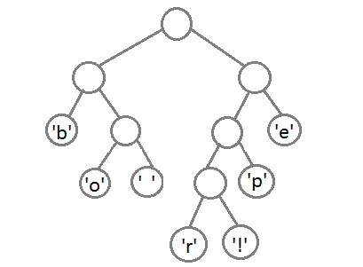

00 11 11 101 011 00 010 010 101 011 00 11 11 1000 1001

beep boop beer!

